**Onion Router Protocol (TOR)**

**Abstract :-**

The Internet develop rapidly at present, to access a large number of pages has become part of the daily life of people, the collection and analysis of private information data has become a business trend in an online world with open and perfect information and diversified information collection. The emergence and application of Tor1 help people achieve the protection of personal information privacy, and allow Internet users to visit the page, meanwhile maintaining the anonymity of their identity information.

The Hidden Service provided by Tor anonymous network can effectively protect the anonymity and security of the Hidden server through the analysis of the data packet structure of Tor, three jump transmission mechanism and link establishment protocol and Hidden Service communication process, in view of the Hidden node number too much, link building Service for too long and too redundant link problem. An improved hidden service model HS-HS is proposed that incorporating multiple transmission link and reuse, and at the same time will be important transit point for reuse protection link anonymity, through the ExperimenTor simulation environment test, verify the improved model of HS-HS can be more effective in guarantee anonymity and security, improve the overall efficiency of data transmission, to meet the needs of today's anonymous service.

**Methodology:-**

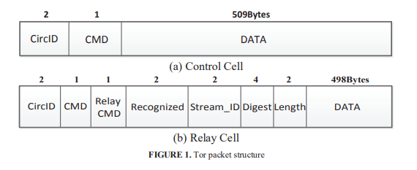

Tor Protocol : Tor is an established distributed anonymous network to protect the identity anonymity of the user side, by analyzing the Tor packet structure, component layout and link handshake protocol, combines the establishment process of link, and fully restores the operation mechanism and protocol deployment of Tor network .

The Tor network uniformly uses the Cell packet structure as the smallest unit, in order to realize the hide of data stream, the total length of the data header and data information are 512Bytes, and the entire Tor communication network is filled. Fig.1 shows the basic structure of the Tor packet structure.

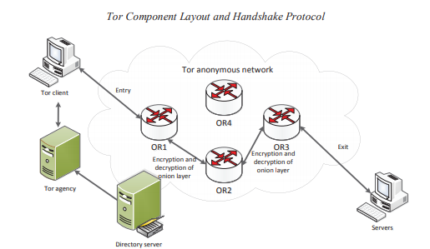

**Fig.2**

The basic network layout of Tor is shown in Figure 2, different components undertake important role of different key nodes in the Tor network:

1. Tor client: The client initiates a communication request and opens the link Tor network task.

2. Tor agency: It is used to connect to the directory server and download the current active node list, meanwhile carrying out node selection and port monitoring.

3. Onion router (OR): It implements agency transmission and link transmission of Cell packet. 4. Directory server: the directory server saves the onion router information and hidden service information, such as the public key of the router and the hidden service.

And lastly Servers: Servers provide normal Web access requests made by the client.

**Results:-**

The establishment and transmission mechanism of Tor and Hidden Service is an improved anonymous information acquisition model HS-HS is proposed for the construction and transmission vulnerability of hidden services. This model increases the efficiency of link establishment and data transmission to a certain extent, the number required of intermediate points is reduced, and the security and credibility of anonymous communication are increased without reducing the anonymity condition of anonymous networks.

**References:**

• <https://youtu.be/6czcc1gZ7Ak>  
• <https://aip.scitation.org/doi/pdf/10.1063/1.5005184>

Names of team members:-

Devansh Shah - 1914078

Kevin Joshi - 1914092

Kaushal Binjola - 1914094